**FIT3179 DATA VISUALISATION** Homework Assessment Week 9

Dhivyan Sureshkumar 32466951 Lab: Studio 11 Tutor: Ria Kalachetty

URL: <https://dhivyan27.github.io/Week9_Homework/>

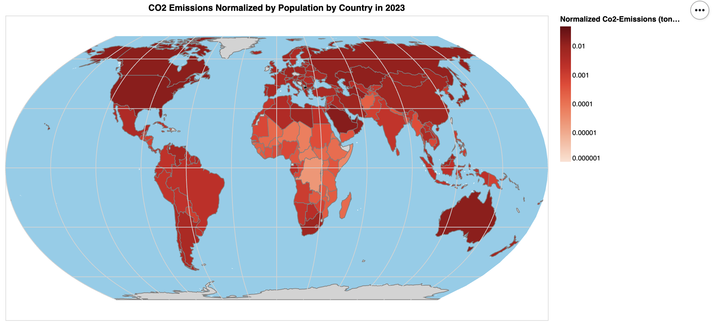

**The domain of your visualisation:**

* The visualisation focuses on presenting CO2 emissions (per person) by country for the year 2023 on a global scale.

**The visualised dataset:**

* Attribute Types: The primary attributes used are country names (properties.NAME), CO2 emissions (Co2-Emissions), and the calculated attribute Normalized-Emissions which is the CO2 emissions normalized by the population of each country.

.

Source and Author:

* The geographical data comes from two TopoJSON sources: `oceans.topojson` and `ne_110m.json`.
* The CO2 emissions data is sourced from Kaggle “Global Country Information Dataset 2023” by Nidula Elgiriyewithana

**Data transformation that you applied:**

* The visualisation employs a choropleth map to display normalised CO2 emissions by country. In order to represent the vast range of emission values effectively on the choropleth map, a logarithmic scale was chosen for the colour encoding.
* Using a logarithmic scale ensures that countries with both high and low emissions are visually distinguishable. This transformation is especially pertinent for data that spans several orders of magnitude, allowing for clearer visualization of patterns and making it easier for viewers to grasp the relative differences in emissions across countries.

**Justification for the type of map idiom used:**

* The visualisation uses a choropleth map to represent CO2 emissions by country. Choropleth maps are particularly effective when visualizing data that varies continuously over a region, such as CO2 emissions by country.
* A choropleth map was chosen over other map types like proportional symbol maps or dot maps because it allows for an immediate visual comparison of emissions intensity across countries. The colour gradation effectively communicates the relative magnitude of emissions, making it easier for viewers to discern patterns and outliers.
* Additionally, the logarithmic scale was employed to handle vast disparities in emission values between countries, ensuring that countries with lower emissions are still visibly represented on the map.